Our scrum backlog made use of Kanban and as such we believed Trello was best suited for it. You can view our scrum log over at <https://trello.com/b/BJbr1mXU/group-8>

I have also included screenshots below. I invited yourselves to join the board to receive instant notification’s, but I understand that you may not want too.

I’m sure you already know what Kanban is, but I believe that it suited our agile design methodology perfectly, in that it allowed us to visually see the quick progression of development and what anyone person needed to do at any point in time.

For example:  
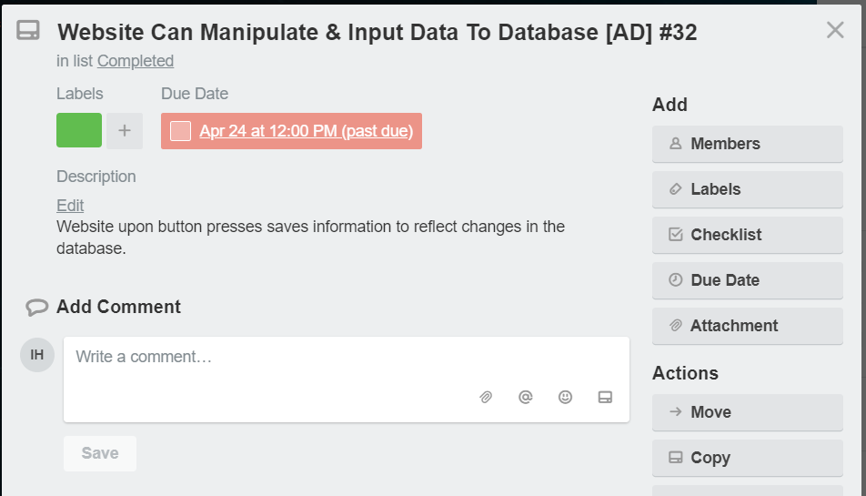

You can see who’s actioned too [AD] when it’s due and what it entails and the ID for any questions. We can also comment on issues. Although best practice is to comment on the WhatsApp.

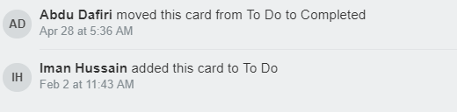

Rich notifications also allow us to see when items are due and when they’ve been completed.

Below I have included the entire Trello board. But once again I do stress that to see the effort and time we’ve put into our planning stage to visit it on the internet. https://trello.com/b/BJbr1mXU

